**4.Git-HOL**

1. **Verify if master is in clean state.**

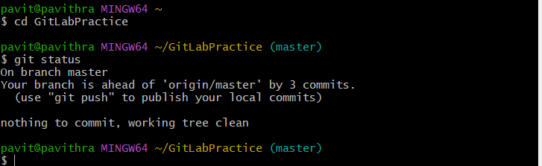

1. 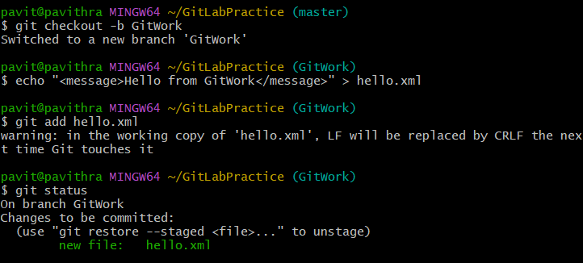**Create a branch “GitWork”. Add a file “hello.xml”.**
2. **Update the content of “hello.xml” and observe the status**

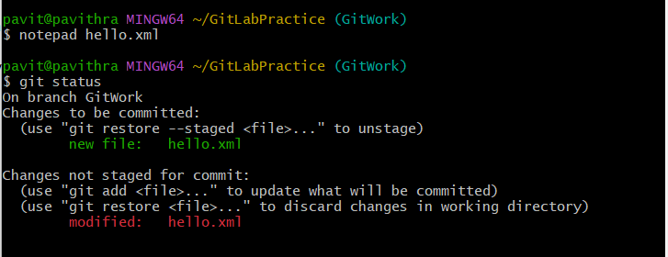

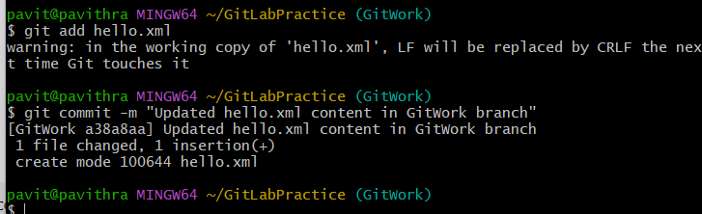 **4.Commit the changes to reflect in the branch**

**5.Switch to master.**



**6.Add a file “hello.xml” to the master and add some different content than previous.**

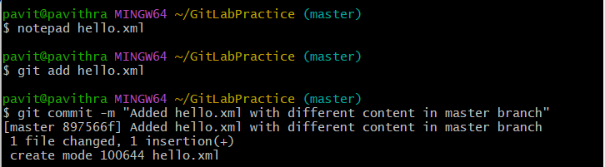

**7.Commit the changes to the master**

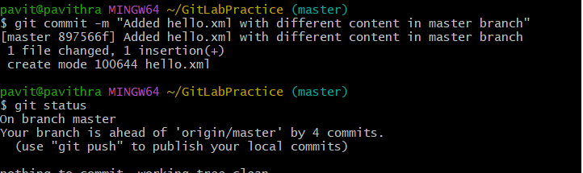

**8.** **Observe the log by executing “git log –oneline –graph –decorate –all”**

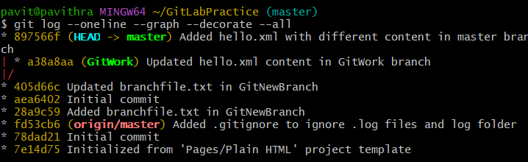

**9.Check the differences with Git diff tool**

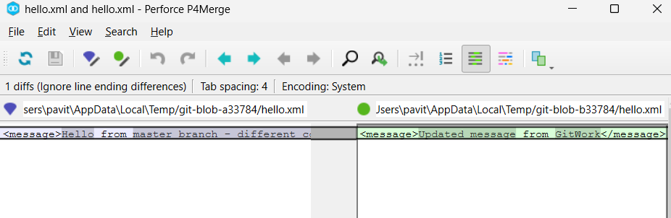

**10.For better visualization, use P4Merge tool to list out all the differences between master and branch**

**11.Merge the bran to the master**

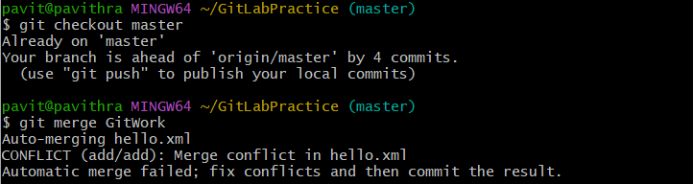

**12.Observe the git mark up.**

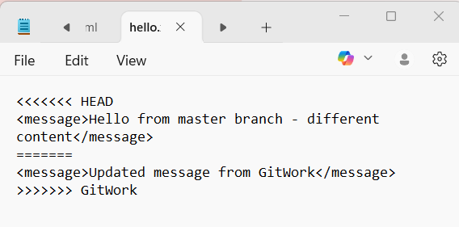

**13.Use 3-way merge tool to resolve the conflict**

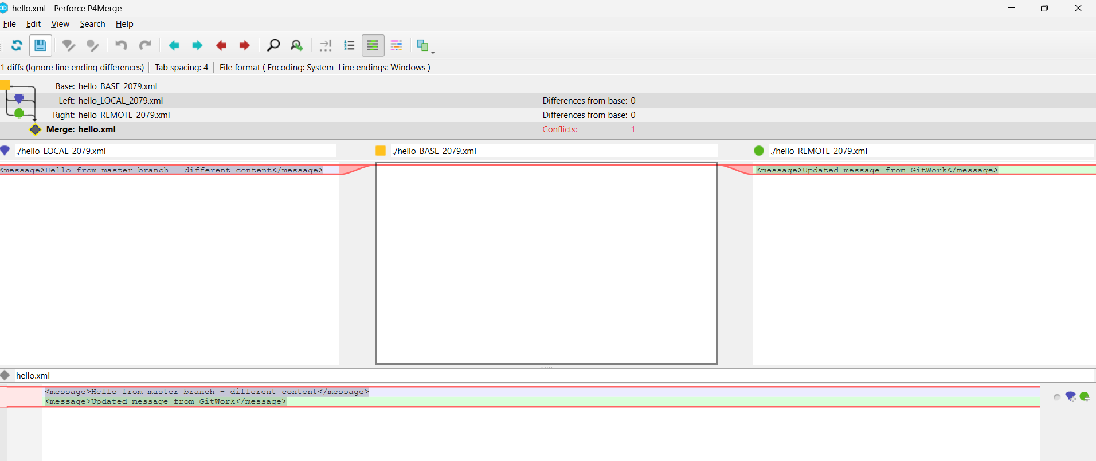



**14.Commit the changes to the master, once done with conflict**



**15.Observe the git status and add backup file to the .gitignore file.**

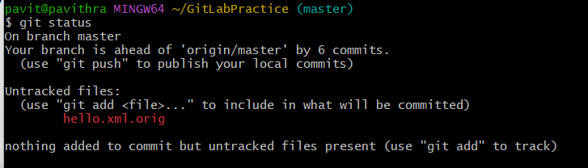

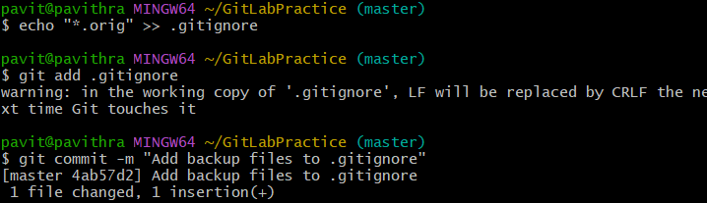

**16.Commit the changes to the .gitignore**



**17.List out all the available branches**

**18.Delete the branch, which merge to master.**



**19.Observe the log by executing “git log –oneline –graph –decorate”**

